**Day 2:**

**Gene Annotation**

Protein Name: **ephrin-B2 [Homo sapiens]**

Protein ID - URS64290.1

**Find the following Gene function details**Location- Start and end, 216 amino acids

Family, [**IPR031328**](https://www.ebi.ac.uk/interpro/entry/InterPro/IPR031328/)

Clan,

Domain, [**IPR001799**](https://www.ebi.ac.uk/interpro/entry/InterPro/IPR001799/)

Motif,

E value 8.8e-90 and

Description of function: A lipid bilayer along with all the proteins and protein complexes embedded in it and attached to it.

**Day 3: Phylogenetics**

**Construct a Phylogenetic tree for components of Corona virus.**

You can choose any gene/protein/component associated with Corona virus for atleast 5 different species/variants. Add the screenshot of the tree here.

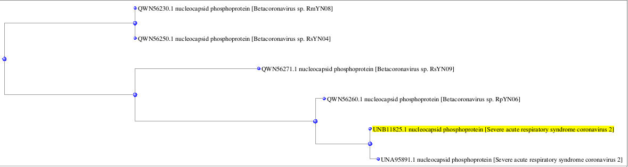

Sars cov2 [**nucleocapsid phosphoprotein**](https://blast.ncbi.nlm.nih.gov/Blast.cgi)

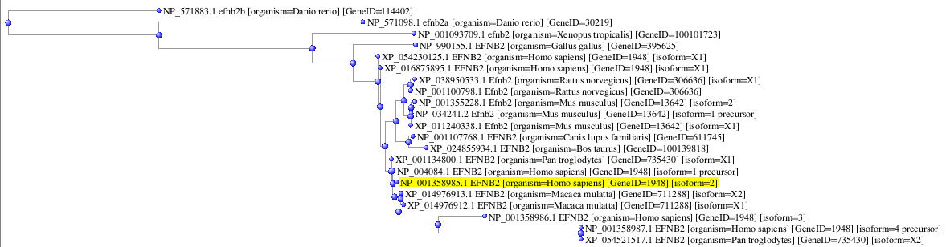

**EFNB2_HUMAN**

**Day 4:**

**Genome name( the one of your interest):**

**From RAST results:**

*Mention the desired nucleotide sequence that you choose to perform BLAST on and fill in the following:*

1. Nucleotide sequence –  **1-660**
2. Location on the genome – NP_828860
3. Start and end nucleotide – start – a(1) and end – t(660)
4. Function - SARS-CoV nsp1 is likely a critical virulent factor with multiple effects on the virus-host interaction interface, such as inhibiting host mRNA translation antagonizing IFN signaling and inducing inflammatory cytokines and chemokines

**Perform a BLAST on the nucleotide sequence and paste a screenshot of the obtained BLAST results:**

**Day 5 & 6:**

**Molecular Docking**

Protein Name: Cryo-EM structure of SARS-CoV2 RBD-ACE2 complex

Protein ID - 7DQA

| Ligand Name | Ligand ID | Follows Lipinski Rule? | Energy value | Dock Image |
| --- | --- | --- | --- | --- |
| Zanamivir | 60855 | 2 violations | -6.3 | Zanamivir.PNG |
| remdivisir | 121304016 | 2 violations | -8.2 | remdivisir.PNG |
| Acyclovir | 135398513 | no violations | -6.0 | Acyclovir.PNG |

**Day 7:**

**Day 8 & 9: Homology Modelling:**

You can choose any protein which is involved in SARS CoV-2 Pathogenesis (Eg: ACE2 receptor, Any envelope protein) and can take at least 2 homologous sequences with sequence similarity >30%. Try to develop an hypothesis around it (Like Why you want to use Homology modelling for your protein of interest, Purpose and outcome of it) and more importantly how it is going to add value to your hypothesis.

**Protein:** **Ephrin-B2**

**Gene:** **EFNB2**

**PDB:** 2VSM

| **Target** | **Sequence** | **Result** |
| --- | --- | --- |
| **moldoc1.PNG** | **moldoc2.PNG** | **moldoc3.PNG** |

**Day 10:**

Please paste your GitHub account link: